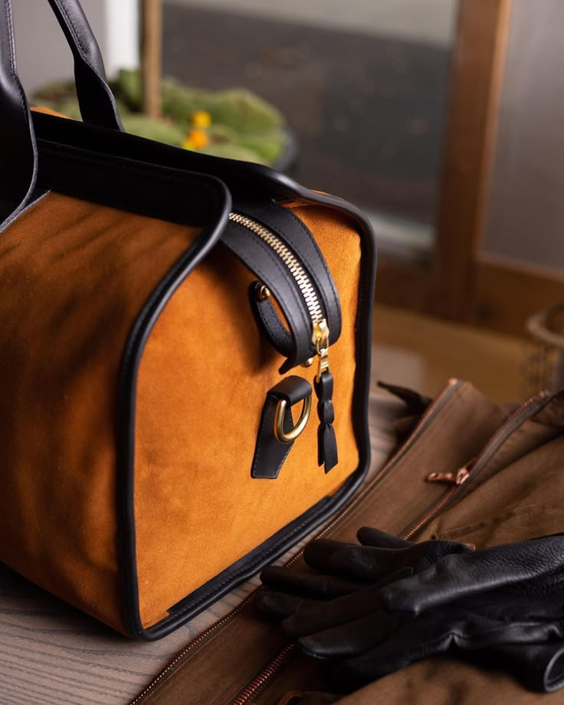Product Details

Product name : Heritage Leather Duffle.

**[**Heritage Leather Duffle **image]**

**Brand : NEXTAG**

**Model : Avs-9181-ybl**

**Price: PKR 2,000**

**Description:**

This is a high-quality leather duffle bag in a rich tan color, featuring a structured silhouette, sturdy handles, and a side zipper with a key-lock detail. It exudes elegance and durability, perfect for travel or daily use

**Grain Leather**  
**Material (Grain Type):** durable, natural-textured, and prized for its strength and aging beauty.

**Maintenance:** Requires regular conditioning to keep the leather soft and prevent drying.

**Usage Guidelines**

**Cleaning:** Wipe with a soft, damp cloth; use leather cleaner for deep cleaning.

**Conditioning:** Apply leather conditioner periodically to prevent drying and cracking.

**Storage:** Keep in a cool, dry place; avoid direct sunlight and humidity.

**Protection:** Keep away from water, oils, and harsh chemicals to maintain texture.

**Warranty Coverage**

This warranty applies to defects in materials and craftsmanship, including:

Faulty stitching or loose seams

Hardware issues (broken zippers, buckles, or clasps)

Defects in leather or fabric (not due to natural aging)

**Exclusions**

This warranty does not cover:

Normal wear and tear, scratches, stains, or discoloration

Damage caused by improper use, accidents, or modifications

Exposure to extreme conditions (water, heat, chemicals)

**How to Claim Warranty**

To request a warranty claim, please provide:

1. Proof of purchase (receipt or order confirmation)
2. Photos of the defect
3. A brief description of the issue